**Individual Requirements Analysis for Semester Project**

*By: Matt Pilgrim*

**Introduction**

I will be working mainly in the backend with retrieving API endpoints and connecting the endpoints to the front end. My job is to gather the API endpoints and use this information to display data to certain objects on the front end. We plan on using the location data of the contributors to display on a map across the United States. We also want to create a piece of data that displays the top 5 contributors of a certain state when you click on it.

**Software Product Overview**

Our overall goal for this project is to display the locations of the contributors in the Augur database on a map of the United States. The locations will be displayed with pins for the users to see. This gives a visual representation for the user of the program about where contributors are across the United States. Once we have the data of the locations, we can sort it out by State and find out the top 5 contributors of every state. In this case, we can make a responsive map that can display certain data when a specific state is clicked. Through these API endpoints, here are many things we can do to help users visualize specific aspects of the Augur database.

System Use Actor Survey The system will be used by others that need to visualize where the contributors are to a github repo. This may be companies that are looking to relocate or are looking for areas to hire people with similar skills to their top contributors.

**Use Cases**

1. User Login

The user will go to the login page, they will enter their account info if they have any to login to Augur to have a more specialized experience.

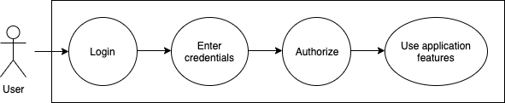

1. Fetching data from the API (to get latitude and longitude)

This is a use case diagram that is used for getting the position of a contributor from the Augur database. The person will open the page at which point the page will ping the api to try and receive the data to fill the google map with pins using the Google Maps Javascript API.

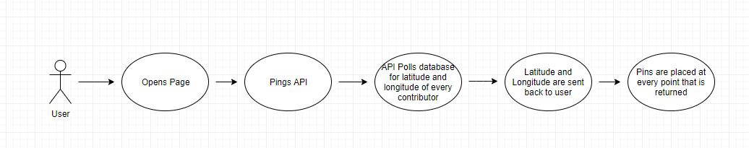

1. Display graph that brings up the cities when you click on the state

This is a use case for describing what happens when you click on a state on the Google Maps map. It will bring up the cities with the top contributors from that state and then it will take that data and use it to visualize some other form of data.

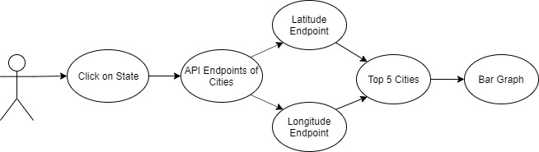

**Functional Specification**

The page will have a login. Once passed the login it will have a map of the United States. It will use latitudes and longitudes provided by the API endpoint in order to place pins on the map. The pins will be grouped by state. The pins show us the locations of users and we can use that data to populate graphs that show different things about those users from the API. You must be able to search for a contributor. You must be able to click on a state.

**Non Functional Requirements**

Must be a responsive map

Must be able to scale to the whole world in the future

Must be able to handle a bunch of users on the site at once.

Must be able to update when a new user is added to the database.

Must be able to easily add more functionality to the front end of the site.

**Design Constraints**

Must only get latitudes and longitudes in the United States

Must place pins on map to represent a contributor

Must be able to click on states

Must be able to search contributors

Must be able to sort contributors by state

You can only click on one state at once.

**Interfaces**

The interface that we will use is the Augur API endpoint that we create to get the latitude and longitude of every contributor. This will be an endpoint that is called in a fetch function and returns a JSON of all the latitudes and longitudes to be parsed. Once parsed this data can be used in the rest of the project environment.